AN ONLINE VOTING SYSTEM WITH ENHANCED SECURITY AND TRANSPARENCY
BY
ABE DAVID TEMILOREOFEJESU 22/1929
ASIWAJU JAMES OLAWUNMI 22/2263
OKOMADU OGHENETEJIRI OSCAR 22/0703
A PROJECT WORK SUBMITTED IN PARTIAL FULFILLMENT OF THE
REQUIREMENTS FOR THE AWARD OF BACHELOR OF SCIENCE B.SC(HONS) DEGREE IN COMPUTER SCIENCE
TO THE DEPARTMENTOF COMPUTER SCIENCE, SCHOOL OF
COMPUTING SCIENCES BABCOCK UNIVERSITY, ILISHAN REMO
OGUN STATE NIGERIA
MARCH, 2026.
PROJECT SUPERVISOR: DR. AWODELE SIMON
DECLARATION
We declare that the project work, AN ONLINE VOTING SYSTEM WITH ENHANCED SECURITY AND TRANSPARENCY, was carried out by the following people:

NAME MATRIC NUMBER

NAME MATRIC NUMBER

NAME MATRIC NUMBER

CERTIFICATION
We certify that the project was carried out by the underlisted students under the supervision of the Department of Computer Science, School of Computing Sciences, Babcock University, Ilishan-Remo, Ogun State.
ABE DAVID TEMILOREOFEJESU 22/1929
ASIWAJU JAMES OLAWUNMI 22/2263
OKOMADU OGHENETEJIRI OSCAR 22/0703

………………………………… …………………..
DR. AWODELE SIMON DATE
PROJECT SUPERVISOR

……………………………………………... ……..…………………..
EXTERNAL EXAMINER DATE & SIGNATURE

…………………………………… ……………………..
DR. EBIESUWA S. DATE
(Head. Department of Computer Science)
DEDICATION
This research project is dedicated to God Almighty, the ultimate source of all wisdom, strength, and inspiration.
It is also dedicated to our loving parents, families, and friends, whose endless support, sacrifices, and encouragement have been our greatest motivation throughout this academic journey. Finally, we dedicate this work to the advancement of transparency, security, and integrity in digital democracy.
ACKNOWLEDGEMENT
We would like to express our deepest gratitude to God Almighty for granting us the strength, wisdom, and perseverance to successfully complete this project.
Our sincere appreciation goes to our supervisor, Dr Awodele Simon, for his invaluable guidance, patience, and constructive feedback throughout this journey. His support, technical insight, and encouragement played a crucial role in shaping the direction and quality of this work.
We also extend our heartfelt thanks to our families and friends for their unwavering support, motivation, and understanding during the long hours and challenges we faced. Their constant belief in our potential kept us going when the workload was overwhelming.
To our course mates, lecturers, and everyone who contributed to the success of this project in one way or another whether through shared knowledge, moral support, or technical advice we sincerely appreciate you.
Thank you!
ABSTRACT
Traditional institutional voting systems are frequently plagued by challenges ranging from high administrative costs and logistical bottlenecks to critical concerns regarding security, transparency, and the integrity of results. This project presents the development of an "Online Voting System with Enhanced Security and Transparency," a web-based artifact designed to address these vulnerabilities through a robust digital framework.

Utilizing the Design Science Research (DSR) methodology and an Iterative Software Development Life Cycle (SDLC) model, the system was built using a decoupled 3-tier architecture consisting of a React.js frontend, a Node.js backend, and a MySQL relational database. To ensure maximum data integrity and voter privacy, the project implements 3rd Normal Form (3NF) database normalization and a structural isolation strategy that prevents direct links between voter identities and cast ballots.

The system’s core security is bolstered by an "Electoral Roll" (Voter Registry) logic, which limits participation to authorized student IDs for specific elections. Furthermore, transparency is achieved through the integration of verifiable Audit Logs and real-time turnout analytics, allowing administrators to monitor election health without compromising the anonymity of the vote. Advanced protections, such as Bcrypt password hashing, JSON Web Tokens (JWT) for role-based access control, and time-bucketing of ballot timestamps to prevent side-channel correlation, were implemented to defend against common cyber threats.
The result is a scalable, user-friendly, and highly secure platform that promotes democratic participation while providing a verifiable audit trail. This research demonstrates that through the strategic application of modern web technologies and rigorous architectural design, institutional elections can achieve a high standard of transparency and reliability in a digital-first environment.
TABLE OF CONTENTS
DECLARATION ................................................................................................. 2
CERTIFICATION ............................................................................................... 3
DEDICATION ................................................................................................... 4
ACKNOWLEDGEMENT ..................................................................................... 5
ABSTRACT ....................................................................................................... 6
CHAPTER ONE: INTRODUCTION
1.1 Background to the Study .............................................................................. 12
1.2 Statement of the Problem ............................................................................. 13
1.3 Aim and Objectives ....................................................................................... 13
1.4 Methodology Overview ................................................................................. 14
1.5 Scope of the Study ....................................................................................... 15
1.6 Significance of the Study .............................................................................. 15
1.7 Organization of Subsequent Chapters .......................................................... 16
References .......................................................................................................... 16
CHAPTER TWO: LITERATURE REVIEW
2.1 Conceptual Framework ................................................................................. 18
2.2 Theoretical Framework ............................................................................... 19
2.3 Review of Related Literature and Empirical Studies .................................... 20
2.3.1 Security, Cryptography, and Verifiability ............................................ 20
2.3.2 Blockchain and Decentralized Architectures ...................................... 20
2.3.3 Usability, Trust, and Socio-Technical Factors .................................... 21
2.3.4 Real-World Implementation and Hybrid Systems ............................... 21
2.4 Summary of the Literature Reviewed .......................................................... 22
References ........................................................................................................ 23
CHAPTER THREE: RESEARCH METHODOLOGY AND SYSTEM DESIGN
3.1 Research Design ........................................................................................ 25
3.2 System Development Methodology (SDLC model) ......................................26
3.3 System Requirements ................................................................................ 26
3.3.1 Functional Requirements .................................................................. 27
3.3.2 Non-Functional Requirements ........................................................... 28
3.4 System Architecture and Design Tools ....................................................... 30
3.4.1 System Architecture .......................................................................30
3.4.2 Design Tools................................................................................. 31
3.5 Project Diagrams ......................................................................................... 31
3.5.1 Use Case Diagram ...................................................................... 32
3.5.2 Data Flow Diagram (DFD) .......................................................... 33
3.5.3 Entity-Relationship Diagram (ERD) ............................................. 34
3.5.4 System Architecture Diagram ..................................................... 35
3.5.5 SDLC Model (Iterative Model) .................................................... 36
3.5.6 Voter Logic Flowchart ................................................................. 37
3.6 System Implementation Environment ......................................................... 42
3.7 Testing and Evaluation Methods ................................................................. 43
CHAPTER FOUR: IMPLEMENTATION
4.1 Introduction ..............................................................................................45
4.2 Authentication and Access Control .............................................................46
4.2.1 Login Mechanism...........................................................................46
4.2.2 Role-Based Routing and Redirection............................................47
4.3 Role-Specific Dashboards.......................................................................50
4.3.1 Super-Admin Dashboard............................................................50
4.3.2 Admin Dashboard.......................................................................51
4.3.3 Voter Dashboard.........................................................................52
4.4 Core Modules and Data Management...................................................52
4.4.1 User and Account Management.................................................53
4.4.2 Election and Candidate Management........................................54
4.5 Processing Workflow............................................................................54
4.5.1 The Voting Workflow..............................................................54
4.5.2 Real-Time Monitoring via WebSockets................................55
4.6 Specified Algorithms and Logic.......................................................56
4.6.1 Audit Logging and Anomaly Detection...............................56
4.6.2 Cryptographic Security........................................................56
4.7 Output Generation and Reporting...................................................57
4.7.1 Election Results Visualization............................................57
4.7.2 System Audit Export.........................................................57
4.8 Technology Stack Summary
CHAPTER FIVE: SUMMARY, CONCLUSION AND RECOMMENDATION
5.1 Summary.......................................................................................59
5.2 Conclusion.....................................................................................60
5.3 Recommendation...........................................................................60
5.4 Future Work...................................................................................61
CHAPTER ONE: INTRODUCTION
1.1 Background to the Study
Elections remain one of the most important pillars of democratic governance, allowing citizens or organizational members to express their preferences through the selection of representatives or policy choices. Traditional paper-based voting systems have served this purpose for decades, but they are prone to human error, logistical inefficiency, and manipulation. As societies and institutions increasingly depend on digital infrastructure, there has been a growing demand for electronic or online voting systems that improve accuracy, efficiency, and transparency in elections (Shahzad et al., 2020).
An online voting system (also referred to as e-voting) allows eligible voters to cast ballots securely through the internet using digital authentication and encryption technologies. These systems aim to simplify election administration, reduce costs, and promote accessibility especially for individuals unable to reach physical polling stations.
However, e-voting introduces new challenges. Concerns such as identity verification, data privacy, vote tampering, and network security must be carefully addressed to ensure that digital elections maintain or exceed the integrity of traditional voting methods (Ali & Al-Harby, 2021). Recent advances in encryption, blockchain technology, and secure web frameworks have shown promise in achieving end-to-end verifiability while preserving voter anonymity (Heiberg et al., 2020).
Therefore, this study proposes the design and implementation of an Online Voting System with Enhanced Security and Transparency, leveraging modern web technologies to demonstrate how secure, auditable, and user-friendly digital voting can be achieved at an institutional level.
1.2 Statement of the Problem
Despite the technological progress in digital communication, many elections both political and organizational continue to rely on manual voting systems that are slow, costly, and susceptible to fraud. Studies have shown that even some electronic systems implemented worldwide have faced vulnerabilities ranging from weak authentication to server compromise and lack of verifiability.
For small- and medium-scale elections, such as university student government or corporate board elections, available solutions are often inadequate, lacking strong security mechanisms and transparent result auditing. This creates a need for an online voting platform that can combine security, integrity, and transparency while maintaining usability for ordinary voters. This project is going to address the security and transparency issues in online voting systems by using methods like blockchain for security and a user-friendly UI for transparency.

1.3 Aim and Objectives
Aim:
The aim of this project is to design and implement an Online Voting System with Enhanced Security and Transparency
Objectives:
- To design a secure architecture that ensures voter anonymity, ballot secrecy, and data integrity through verifiable audit logs.
- To develop core modules for election management and real-time result visualization using a user-friendly interface to enhance participation.
- To validate system performance and reliability through rigorous security testing to ensure data protection and accessibility
1.4 Methodology Overview
This study adopts the Software Development Life Cycle (SDLC) approach using the Iterative model to ensure flexibility and incremental improvement during system development. The methodology will involve the following stages:
- Requirement Analysis: Identification of both functional and non-functional requirements through literature review and consultation with stakeholders familiar with election processes.
- System Design: Developing models using Data Flow Diagrams (DFD) and Entity Relationship Diagrams (ERD) to define process flow, system components, and database structure.
- Implementation: Building the system using Node.js for the backend logic, Express.js for routing, MySQL for database management, and Reacts.js for the frontend interface. HTML will define the page structure, and Tailwind CSS will handle the styling for responsiveness and accessibility. The system will also employ express-session for secure session management and encryption to safeguard communication between clients and the server.
- Testing: Conducting unit, integration, and user acceptance testing to validate functionality, performance, and security features.
- Deployment: Hosting the application on a secure server environment with SSL encryption to ensure data integrity during transmission.
This methodology ensures that security and transparency are embedded at every development stage while maintaining system usability and efficiency.

1.5 Scope of the Study
This study focuses on the design and implementation of a secure and transparent online voting system. The system is intended for small-scale to medium-scale elections such as university student government, union or organizational elections. It will include modules for voter registration, authentication, vote casting, result computation, and result display. The system will not cover large-scale national elections or complex biometric verification due to infrastructural and regulatory limitations.

1.6 Significance of the Study
This project demonstrates how modern web technologies can be harnessed to enhance electoral integrity and public trust in digital voting. It provides a secure, auditable, and transparent framework suitable for small-scale elections and serves as a foundation for future research in e-governance and cyber-security.
The system aligns with the principles of digital transformation and good governance promoted globally by organizations such as the United Nations Development Programme (UNDP), which advocates the use of technology to improve citizen participation and institutional transparency (UNDP, 2021).
Academically, this study contributes to research in secure web applications, cryptographic voting protocols, and human-computer interaction for trustworthy digital elections.
1.7 Organization of Subsequent Chapters
This research report is organized into five chapters:
- Chapter One presents the background, problem statement, objectives, scope, significance, and organization of the study.
- Chapter Two provides a detailed review of related literature, including conceptual, theoretical, and empirical frameworks.
- Chapter Three discusses the methodology adopted for system design, implementation, and testing.
- Chapter Four explains the system implementation process, test results, and analysis of findings.
- Chapter Five concludes the research with a summary, conclusions, and recommendations for future work.
References
Ali, S., & Al-Harby, F. (2021). A survey of electronic voting technologies and their security concerns. IEEE Access, 9, 145367–145391. https://doi.org/10.1109/ACCESS.2021.3122135
Heiberg, S., Laud, P., & Vinkel, P. (2020). Enhancing verifiability and privacy in electronic voting using blockchain technology. IEEE Access, 8, 215162–215175. https://doi.org/10.1109/ACCESS.2020.3040271
Shahzad, A., Kang, S., & Lee, M. (2020). A secure electronic voting system based on blockchain technology. Electronics, 9(2), 185. https://doi.org/10.3390/electronics9020185
United Nations Development Programme (UNDP). (2021). Digitalization and governance: Harnessing technology for inclusive participation. UNDP Policy Brief. Retrieved from https://www.undp.org/publications

CHAPTER TWO: LITERATURE REVIEW
2.1 Conceptual Framework
The conceptual framework for an Online Voting System with Enhanced Security and Transparency is supported by three major pillars, which are authentication, confidentiality, and verifiability.
Authentication ensures that only the eligible voters participate in the election. Secure authentication mechanisms like two-factor verification, digital certificates, or token-based systems prevent impersonation and multiple voting.
Confidentiality ensures voter privacy and secrecy of the ballot. Modern systems make use of cryptographic protocols such as homomorphic encryption, mix-nets, and blind signatures that prevent linking votes to specific voters (Heiberg et al., 2020).
Verifiability allows voters and auditors to verify that votes were cast, recorded, and counted appropriately while keeping the voter's choice undisclosed. End-to-end verifiable systems include Helios and Prêt à Voter, which guarantee this via cryptographic proof and public auditing.
The proposed system integrates these fundamental principles into a secure client-server architecture using React.js, Node.js, and MySQL, leveraging encryption both at the transport and data levels. Real-time dashboards and logs permit transparency without compromising the secrecy of the ballots.
Conceptually, this framework follows the model of trust through transparency (Mercuri, 2001), in which system credibility depends not only on fraud prevention, but also on the ability of stakeholders to verify that the process is fair.
2.2 Theoretical Framework
This research uses theories from information security and electronic governance to support the design of a secure and transparent voting platform.
a. Socio-Technical Systems Theory This theory, by Trist and Bamforth (1951), emphasizes that people, technology, and organizational context are interdependent. In online voting, for instance, system usability and user trust are as crucial as cryptographic strength. A system which is technically secure but difficult to use might discourage participation or lead to human errors (Volkamer & Stark, 2015).
b. Cryptographic Trust Model Online voting relies on mathematical assurance and not on institutional trust. PKI represents the foundation of authentication and integrity of data, based on the work of Rivest & Wack (2006). Every voter will have a private-public key pair, which allows secure vote transmission and verification, but not identification.
c. Transparency and Accountability Theory According to Bovens, 2007, transparency makes processes more visible to stakeholders, hence enhancing accountability. In e-voting, this theory supports the openness in the audit mechanisms that would permit voters, observers, and administrators to verify system behaviour while maintaining privacy.
Taken together, these theories can form a basis for a socio-technical, cryptographically sound, and transparent e-voting architecture suitable for use within institutions and organizations.

2.3 Review of Related Literature and Empirical Studies
Research on e-voting systems encompasses such issues as technical security and user trust, through to real-world implementations. The following review synthesizes the key empirical and related studies, organized by their primary thematic focus.

2.3.1 Security, Cryptography, and Verifiability
The cryptographic underpinning of e-voting is where a large body of the literature rests. Rivest & Wack (2006) provided a basic building block, "software independence," meaning a system’s correctness should not depend on any single software component, a central tenet for modern designs. Following this, Zissis & Lekkas (2012) proposed a secure framework for e-voting based on a layered cloud architecture using cryptographic primitives for end-to-end integrity and voter anonymity. More recently, Cortier & Kremer (2018) have been working on formal verification of such cryptographic protocols, showing that model-checking tools are able to find design-level vulnerabilities before deployment.

2.3.2 Blockchain and Decentralized Architectures
The arrival of blockchain has set off serious research into decentralized e-voting. Heiberg, Laud, & Vinkel (2020) proposed a verifiable Internet voting system using blockchain-style append-only logs, showing that cryptographic proofs can ensure voter privacy while enabling public verification. Shahzad, Kang, & Lee (2020) introduced a blockchain-based architecture using Ethereum smart contracts that securely record and validate ballots.
Comparative analyses, like that of Jameel et al. (2022), conclude that decentralized applications outperform centralized databases on auditability and tamper resistance issues. Others have focused on optimization: Chakraborty et al. (2019) designed a lightweight blockchain framework suitable for institutional elections. However, Kshetri & Voas (2018) pointed out that though blockchain strengthens auditability, there are challenges to its scalability and verification of voter identity.

2.3.3 Usability, Trust, and Socio-Technical Factors
According to Socio-Technical Systems Theory, researchers emphasize that usability and trust are as imperative as technical security. Volkamer & Stark (2015) did a study in Germany focused on how usability and trust are essential in the successful adoption of technology. Acemyan et al. (2018) undertook usability testing of end-to-end verifiable systems, Helios, and STAR-Vote, and discovered that clearer interfaces and feedback mechanisms greatly enhanced voter confidence and error detection.
This adoption challenge is also influenced by regional factors: In studying e-voting adoptions in Asian countries, Zhao & Chan (2020) found that infrastructure readiness, regulatory support, and cultural trust strongly influence the success of implementation. Kshetri (2021) further investigated how developing economies might leverage cloud and mobile infrastructures in attempting to deliver secure digital elections, bringing into focus related questions about governance frameworks.

2.3.4 Real-World Implementation and Hybrid Systems
Analysis of real-world systems provides invaluable insight. Alvarez, Hall, & Trechsel (2013) examined international Internet voting projects and determined that while the systems increase ease of access for overseas voters, the central problems pertain to the secrecy of ballots and dependable authentication. Of particular note was the extensive security analysis of Estonia's country-wide Internet voting system provided by Springall et al. (2014), showing client-side vulnerabilities and a lack of verification mechanisms that made manipulation of votes possible. The results of such findings have led many scholars to recommend hybrid approaches. A large-scale review by Ali and Al-Harby (2021) of the contemporary e-voting technologies concluded that hybrid systems, merging traditional cryptography with blockchain, often provide much stronger resistance to insider attacks and better scalability than the purely centralized approach.

2.4 Summary of the Literature Reviewed
A review of the related literature indicated that online voting systems have evolved from simple web-based ballot systems to sophisticated, cryptographically secured, and sometimes blockchain-enabled architectures. On a conceptual level, most of the reviewed works agree that e-voting can increase accessibility, efficiency, and transparency if well implemented. The theoretical models, such as the end-to-end verifiability framework and software independence principle, have provided the basis necessary for secure and auditable systems.
Despite these advances, a gap in the literature is clear: though decentralized blockchain systems are highly transparent Heiberg et al. (2020), Shahzad et al. (2020), and though formal cryptographic models are secure Rivest & Wack (2006), Zissis & Lekkas (2012), there remains a pent-up need for systems that are highly usable Acemyan et al. (2018), scalable, and resistant to client-side vulnerabilities Springall et al. (2014). Many scholars point to hybrid systems as the most promising path forward Ali & Al-Harby (2021).
These findings constitute direct justification for the proposed system in this work. An Online Voting System based on a modern, robust client-server architecture (React.js and Node.js) will try to fill the security and usability gaps on the client side. In addition, with a secure relational database, MySQL, and strong encryption, this solution is practical, centralized but verifiable, and strikes a good balance among security, transparency, and accessibility for institutional use in accord with global best practices.
References
Jafar, U., Aziz, M. J., & Shukur, Z. (2021). Blockchain for electronic voting system review and open research challenges. Sensors, 21(17), 5874. https://doi.org/10.3390/s21175874
Mtepa, J. H., Akintola, I. A., Salem Muftah, A., & Hussain, A. (2018). The evaluation of the electronic voting system: a review. International Journal of Engineering and Technology, 7(3.20), 860-863. https://doi.org/10.14419/ijet.v7i3.20.28405
Azameti, C. Y., Asiedu, W., & Asante, G. (2022). Analysing the potential vulnerabilities in online voting protocols: homomorphic encryption approach. Journal of Computing Research and Innovation, 10(2). https://doi.org/10.24191/jcrinn.v10i2.515
Hajian Berenjestanaki, M., Barzegar, H. R., El Ioini, N., & Pahl, C. (2024). Blockchain-Based E-Voting Systems: A Technology Review. Electronics, 13(1), 17. https://doi.org/10.3390/electronics13010017
Omotayo, F. O., & Adekunle, O. A. (2021). Adoption and use of electronic voting system as an option towards credible elections in Nigeria. International Journal of Development Issues, 20(1), 38-61.
Mishra, A., & Ahmad, A. O. (2019). Design and development of real-time e-voting system with high security features. International Journal of Education and Management Engineering, 9(3), 37-50. https://doi.org/10.5815/ijeme.2019.03.04
Abubakar, J. A., Oluwatobi, A., & Ademola, O. F. (2024). Advancing democratic governance with AIoT-enabled e-voting: A case study of Covenant University’s departmental associations in alignment with SDG 16. In Lecture Notes in Data Engineering and Communications Technologies: Artificial Intelligence of Things for Achieving Sustainable Development Goals (pp. 335-360). Springer. https://doi.org/10.1007/978-3-031-53433-1_17
Wang, B., Guo, F., Liu, Y., et al. (2024). An efficient and versatile e-voting scheme on blockchain. Cybersecurity, 7, 62. https://doi.org/10.1186/s42400-024-00226-8

CHAPTER THREE: RESEARCH METHODOLOGY AND SYSTEM DESIGN
This chapter describes the systematic method followed to develop the "Online Voting System with Enhanced Security and Transparency" project. It provides details on the type of research carried out, the method adopted for software development, the particular system requirements, architecture of the developed system, tools employed during implementation, as well as testing methods.

3.1 Research Design
For this project, the Design Science Research (DSR) methodology is used. Design Science Research is a problem-solving paradigm with a focus on designing and analysing novel information technology artifacts to solve identified real-world problems.
This is the most suitable method for this project because the focus is not just on analysing current voting systems in place. It is to create and develop a brand-new artifact, which is the secure online voting system. This research includes:
- Problem Identification: Identifying the problems of insecurity, a lack of transparency, and high costs associated with traditional voting.
- Define Objectives: Designing a secure architecture that ensures voter anonymity, ballot secrecy, and data integrity through verifiable audit logs
- Design and Development: Development of web-based software utilizing Reacts.js, Node.js, and MySQL.
- Demonstration & Evaluation: This involves proving the artifact solves the problem with testing and evaluation.

3.2 System Development Methodology (SDLC model)
For proper management of the software development process, this project uses the Iterative Software Development Life Cycle model.
The Iterative model is one in which the system is developed in cycles. Every cycle can be built upon to add more functionality to finally develop the complete system. This model is preferred over the Waterfall model for the given project for the following reasons:
- Security Emphasis: Our first concern is security. The Iterative model makes it possible for us to develop and strengthen basic security components (e.g., user login and encryption of votes) in the first iteration.
- Risk Management: It tackles the largest risks earliest. By developing the voting and tallying mechanism core logic in the first cycle itself, we can establish the integrity of our system before adding other functionalities.
- Feasibility: Feedback can be incorporated at the end of each iteration with the flexibility to refine the interface (Reacts.js/Tailwind) and logic (Node.js) to ensure it is more accurate.
- Early Prototypes: A functional prototype of the system can be created quickly that is functional but with little detail.

3.3 System Requirements
System requirements define the precise specifications and limitations the system needs to fulfill.
3.3.1 Functional Requirements
Functional Requirements articulate what the system needs to accomplish. These have been itemized according to roles (admin and voter).
Administrator (Admin) Module:
- The admin login should be done through a secure login page.
- The admin needs a dashboard to control every aspect of the election.
- The admin needs to have Create, Read, Update, and Delete (CRUD) functionality for election positions such as “President” or “Vice President.”
- The admin must have the capability to carry out CRUD actions on Candidates. This includes uploading a name and photo and assigning them to a position.
- The admin manages the Voter Registry (Electoral Roll) by uploading a master list of authorized Student IDs for specific elections to prevent unauthorized participation.
- The admin needs to have the capability to define the election beginning and ending time.
- The admin needs to check the real-time voter turnout percentage or count without viewing individual votes.
- The admin should have the ability to reliably calculate and display the results.
- The Super Admin must have the authority to manage administrator roles, deactivate accounts, and review system-wide Audit Logs to ensure administrative accountability

Voter Module:
- A voter must be able to login with their unique identifier (for instance, Student ID) and a secure password.
- The system must perform a mandatory cross-reference check against the Voter Registry to verify the user is specifically authorized to vote in the selected election.
- The voting system should ensure that a person votes only once.
- The voter must be presented with a simple and understandable voting interface (created with React) that includes all the positions.
- The voter must be able to choose one candidate for each position.
- The voter must be able to submit their vote and receive verification that their vote is recorded successfully and is anonymous.

3.3.2 Non-Functional Requirements
These are non-functional requirements because they define the performance of the system.
Security:
- Authentication: All user passwords have to be hashed (with a strong hash algorithm such as bcrypt) in the MySQL database.
- Authorization: This requires the use of tokens (for example, JSON Web Tokens - JWT) to ensure that only authorized users have access to API routes.
- Confidentiality (Anonymity): The design of the system should ensure that it is not possible to trace a cast vote in the Votes table to the corresponding voter's information in the Voters table. This is enforced through structural isolation where no foreign key exists between the Users and Votes tables.
- Data Integrity: Prevention of SQL Injection through prepared statements and protection against Timing Correlation Attacks via Time Bucketing of ballot timestamps. All data that flows between the React client and the Node.js server must be SSL/TLS (HTTPS) encrypted.
Transparency:
- The system implements a persistent Audit Log that records all administrative actions, including election creation, candidate modifications, and role changes, identified by User ID and IP address.
- The final results have to be correct and obtained exclusively from the anonymized voting data.
Usability:
- The interface or UI, developed using React and Tailwind CSS, should be simple and responsive. It should be easy to navigate for a non-technical person.
Performance:
- The voting system needs to support multiple users' login and voting actions without crashing.
- Database queries need to be optimized to ensure quick display of results.
Reliability:
- System high availability is required during the active voting stage.
- Data integrity is maintained through Atomic Transactions, ensuring that a ballot is only recorded if the voter's status is successfully updated to 'voted'.

3.4 System Architecture and Design Tools
In this section, we detail the system's technical architecture and design tools used to map out its logic and data before we began the implementation

3.4.1 System Architecture
The system utilizes a decoupled 3-Tier Architecture (Presentation, Logic, and Data) to ensure that security policies are strictly enforced at the server level before any data is committed to the database.
These tiers include:
- Presentation Tier (Client-Side/UI): This is the interface. It is client-based (runs on the web browser in the voter or admin's machine) and is charged with displaying information and obtaining input.
Technology: React.js, HTML, and Tailwind
- Logic Tier (Server/Backend): This is “the brains” of the application. This tier is server-based and is home to all business logic operations. It is responsible for client requests and security policies. This tier is the link between the client and database.
Technology: Node.js with the Express.js framework to develop a RESTful API.
- Data Tier (Database): The data tier or database handles storing and controlling data related to the entire application, such as data associated with users, candidates, and the anonymous votes.
Technology: MySQL Relational Database Management System (RDBMS)
The physical and logical separation of these tiers is further detailed in the 3-Tier System Architecture Diagram, illustrating the isolation of the Data Tier from direct user access.

3.4.2 Design Tools
For modelling the system before it is implemented, the following standard tools shall be employed:
- Use Case Diagrams (UML): To model the interactions between the actors (e.g., Admin, Voter) and the key functionalities of the system (e.g., “Cast Vote,” “Manage Election”).
- Data Flow Diagram (DFD): For representing data flows within the system. For instance, representing the voting data flow process that spans from when the voting is done until it's stored in the database.
- Entity-Relationship Diagrams (ERD): For designing the logical structure of the MySQL database. This ERD will define the tables (Entities) such as Users, Elections, Positions, Candidates, Voter Registry, Voter Status, Votes, and Audit Logs., and their interrelation.
- Voter Logic Flowchart: Used to map the rigorous security checks (Eligibility and Participation) performed by the backend before a ballot is accepted.
- Sequence Diagram: Illustrates the step-by-step communication between the Client, Middleware, Controller, and Database, specifically highlighting the implementation of Atomic Transactions.
- SDLC Model Diagram: Visually outlines the Iterative development cycles used to build and evaluate the system's security features.

3.5 Project Diagrams
This is the visual representation of the design tools used in this project. This is for easy understanding.

3.5.1 USE CASE DIAGRAM (UML)
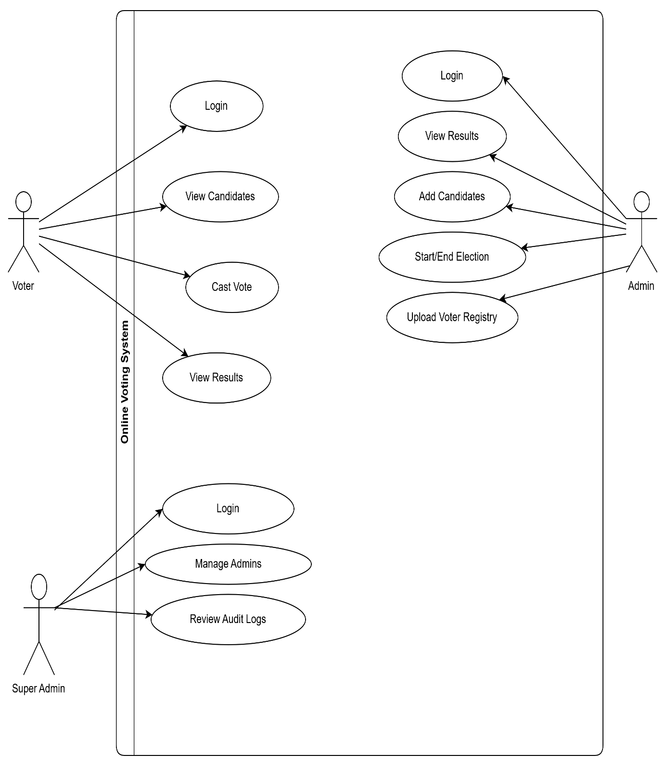

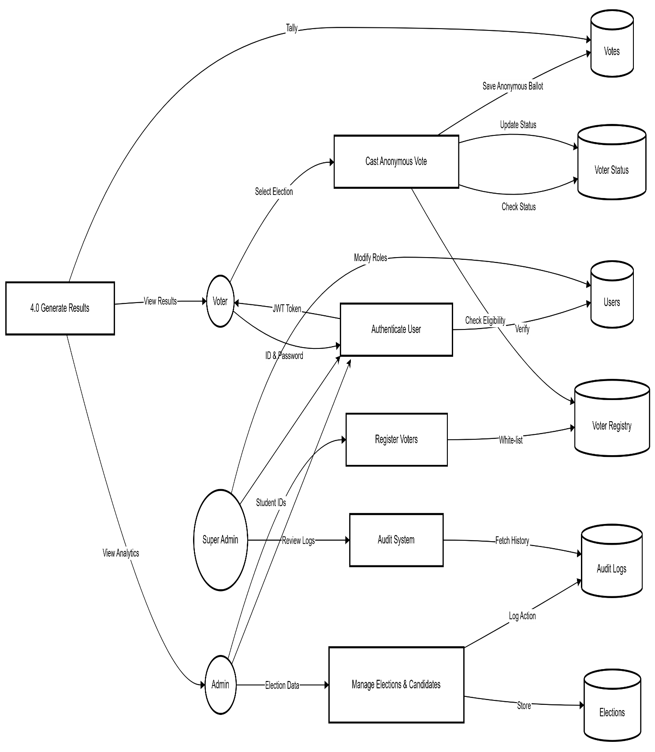
3.5.2 DATA FLOW DIAGRAM (DFD)

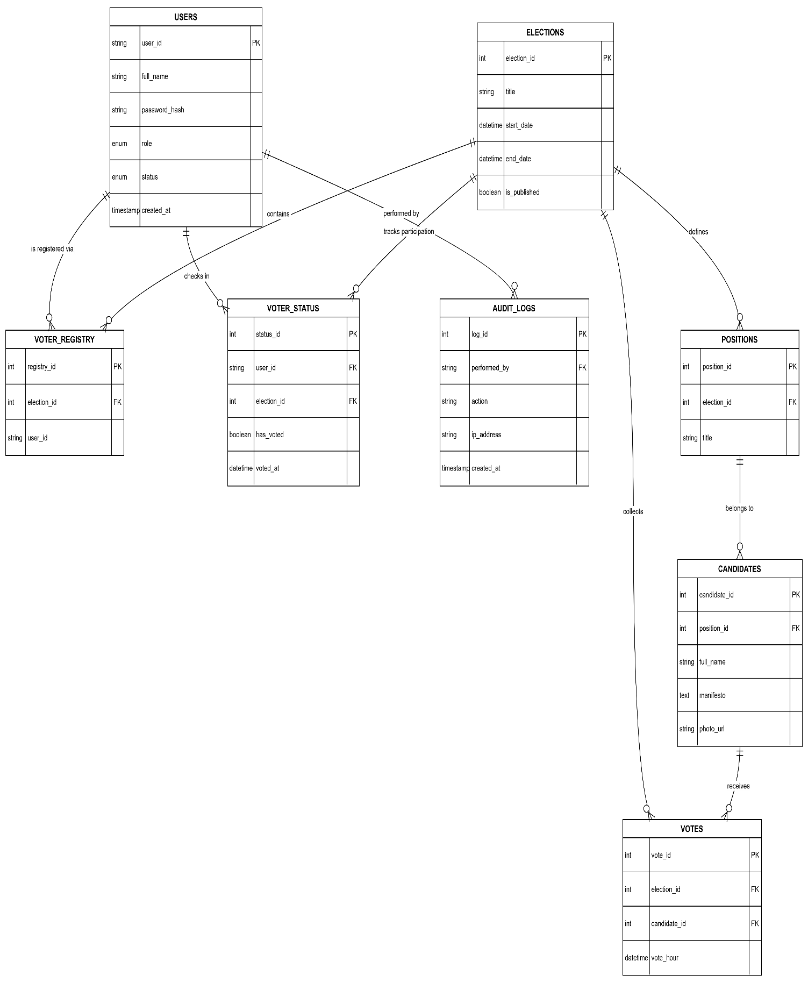
3.5.3 ENTITY-RELATIONSHIP DIAGRAM (ERD)

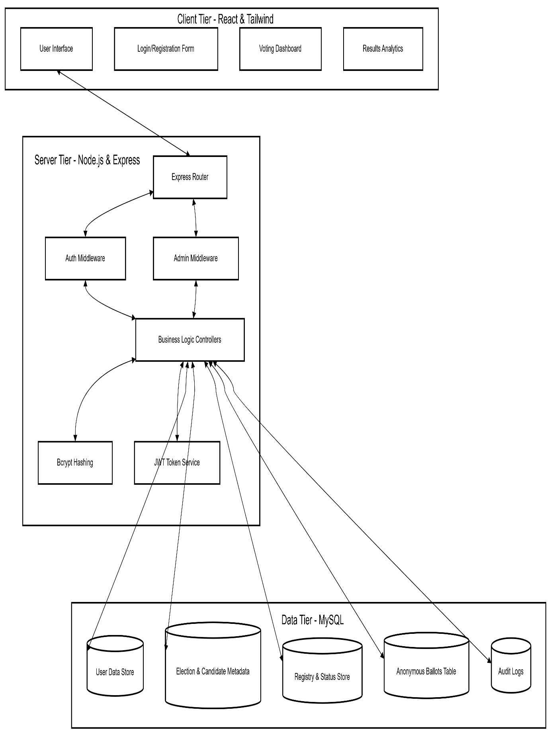
3.5.4 SYSTEM ARCHITECTURE DIAGRAM

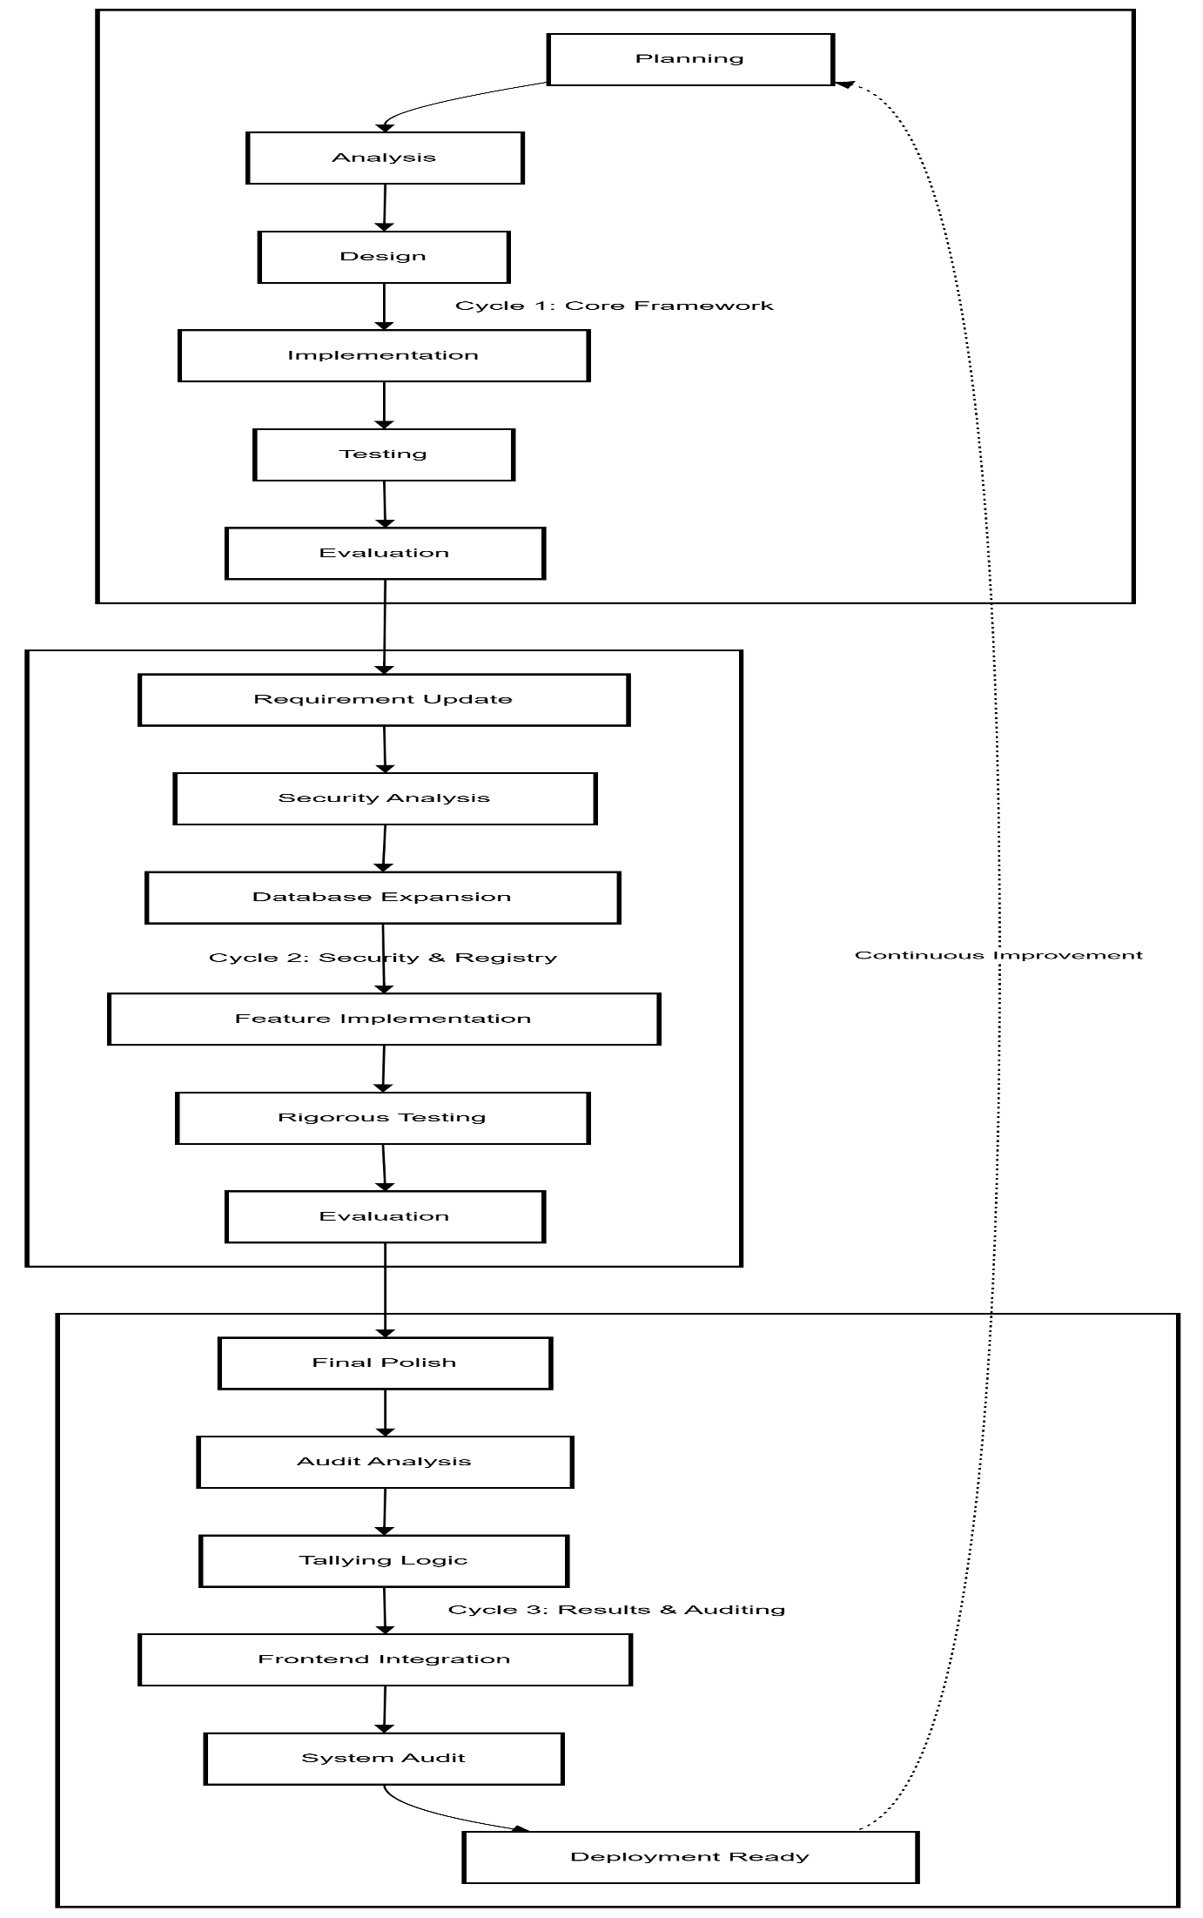
3.5.5 SDLC MODEL (ITERATIVE MODEL)
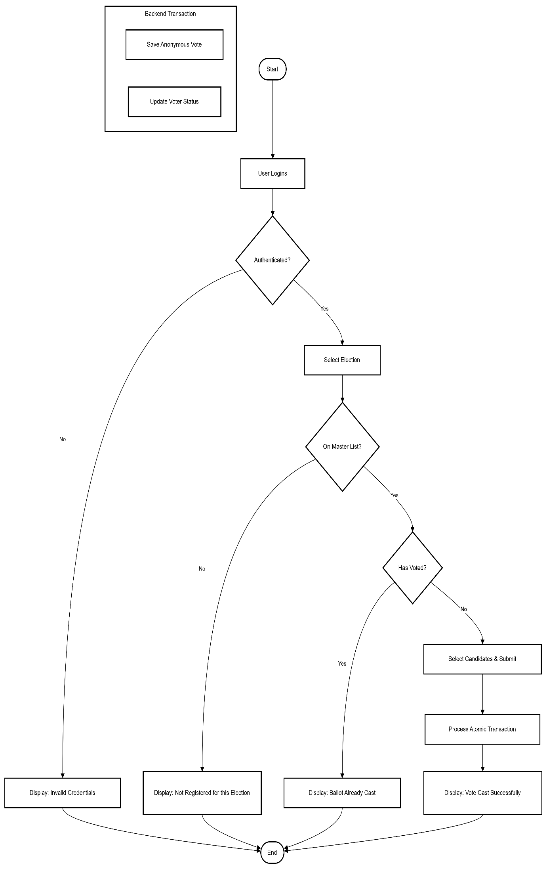
3.5.6 FLOWCHART
Pseudocode: Anonymous Ballot Casting

ALGORITHM CastSecureVote
INPUT: userId, electionId, candidateId

// Step 1: Authorization Check
IF (User.Role IS NOT 'voter')
RETURN "Error: Unauthorized access"

// Step 2: Eligibility Check (Master List)
IF (userId NOT IN voter_registry WHERE election_id = electionId)
RETURN "Error: Not eligible for this election"

// Step 3: Participation Check
IF (userId IN voter_status WHERE election_id = electionId AND has_voted = TRUE)
RETURN "Error: Ballot already cast"

// Step 4: Atomic Transaction
START TRANSACTION
TRY
// Record vote anonymously
INSERT INTO votes (candidate_id, election_id, vote_hour)
VALUES (candidateId, electionId, CURRENT_HOUR_ROUNDED)

// Mark user as having voted
INSERT INTO voter_status (user_id, election_id, has_voted, voted_at)
VALUES (userId, electionId, TRUE, NOW())

COMMIT TRANSACTION
RETURN "Success: Vote recorded"

CATCH Error
ROLLBACK TRANSACTION
RETURN "Error: Transaction failed"
END ALGORITHM

System Workflow
The system follows two distinct pathways based on the user's role.
Voter Workflow
- Identity Verification: User enters User ID and Password. System returns a JWT.
- Election Discovery: Voter views a list of "Active" elections they are registered for.
- Ballot Interface: Voter views candidates and manifestos.
- Security Gate: System verifies Registry status and previous participation.
- Submission: Anonymous ballot is cast; UI updates to show "Completed."
Admin/Super-Admin Workflow
- System Oversight: Super Admin manages Admin permissions and reviews Audit Logs.
- Election Setup: Admin creates Election metadata and defines positions.
- Electoral Roll: Admin uploads a list of User IDs (Registry) allowed to vote.
- Turnout Monitoring: Admins monitor real-time percentage turnout.

The Frontend (Client-Side)
- Techniques: Component-based architecture using React.js and Vite.
- Styling: Tailwind CSS for a responsive, mobile-first design.
- State Management: React useState and useEffect hooks to manage the voting session and dashboard data.
- Responsiveness: The UI adapts to smartphones and tablets so students can vote from anywhere.
The Backend (Server-Side)
- Techniques: RESTful API built with Node.js and Express.js.
- Database: MySQL using a connection pool for high concurrency (multiple users voting at once).
- Security: * Bcrypt.js: Salting and hashing passwords.
  - JWT: Stateless authentication to keep the server fast.
  - Transactions: Ensuring database integrity during voting.

5. Communication (The "Link")
The frontend and backend communicate via Asynchronous HTTP Requests (AJAX) using the Axios library.
- The Bridge: All requests are sent to a base URL (e.g., http://localhost:5000/api).
- The Security Guard: An Axios Interceptor is used in React. It automatically pulls the JWT token from the browser's storage and attaches it to the "Authorization" header of every request.
The Response: The Backend sends data back in JSON format, which React then maps into the UI components (like tables or candidate cards).

3.6 System Implementation Environment
For our implementation model, we shall employ a current technology environment with each component chosen for its superiority.
Frontend (Client-side): For designing the interface, we can use React.js. It is one of the powerful JavaScript libraries used to develop dynamic component-based interfaces. For designing and boosting the interface, we can use Tailwind CSS. HTML5 shall form the backbone for designing.
Backend (Server-side): To implement the backend tasks, we will utilize Node.js. It is a JavaScript runtime environment that provides support for quick and efficient execution of operations on the server. To develop and handle the RESTful API calls at the backend, we will utilize the services offered by Express.js.
Database: For our database part of the project, we decided to work with MySQL. MySQL is a powerful open-source relational database management system that will be able to safely and efficiently store all data related to our project. This includes information on users, shortlists of candidates, as well as the anonymous voting results.
Security: To ensure security at our site, we will include security measures through the adoption of numerous crucial technologies. First, we shall adopt the usage of Bcrypt.js to encrypt and salt every user's password to prevent storage in plain forms. Secondly, we shall adopt the usage of JSON web tokens to maintain secure, stateless user sessions and role-based access control.
Development & Testing: For our development process, we will employ a number of tools. The primary coding environment for every programming task will be the Visual Studio Code (VS Code) IDE. The designing, testing, and documentation of the backend API will be done utilizing the Postman tool. All our project codes will be maintained within a version control system named Git. It will be housed on GitHub.
Data Analysis & Visualization: Lastly, we shall resort to Microsoft Power BI for data analysis. It will interface with our MySQL database to carry out data analyses concerning voting data such as turnout and final results. It will also generate the rich visualizations we shall discuss in Chapter 4.

3.7 Testing and Evaluation Methods
To ensure that our system is reliable, secure, and fulfills all the requirements stated, we shall adopt a testing strategy with multiple phases:
Unit Testing: To test individual parts in isolation (for instance, a component written in react or a method in node.js such as hashPassword) to ensure it is working correctly.
Integration Testing: Components will be tested collectively to identify errors in their integration. This includes testing the overall login functionality that involves the login form in React, the API request to the Node.js server, the database verification check in MySQL, and finally the JWT token response.
System Testing: The whole system will be tested against the functional and non-functional specifications. This includes:
Black-Box Testing: A test of the functionality of the system as perceived by a user without viewing the code (for instance, "Can the admin successfully create an election?").
Security Testing: It is the most crucial assessment. These tests shall include:
- SQL Injection attempts on login forms and input fields.
- Protection against Cross-Site Scripting (XSS) attacks
- Verification that a session token (JWT) belonging to another user cannot be used.
- Manual checks on the database to ensure that the votes cast are indeed anonymous and cannot be traced to the voter.
- Verification of Time Bucketing to ensure timestamps cannot be used to de-anonymize voters through side-channel analysis.
User Acceptance Testing (UAT): A small test group of users (e.g., other students) will be asked to test the software to accomplish tasks such as voting.

Chapter 4: Implementation

Introduction
This chapter details the technical realization of the Online Voting System, a secure and transparent e-voting platform designed to facilitate institutional elections. The implementation leverages a decoupled three-tier architecture, ensuring separation of concerns between the presentation layer, the business logic layer, and the data persistence layer.
The system is built using the MERN stack variation, specifically utilizing React.js for the frontend interface and Node.js with Express.js for the backend RESTful API. Data persistence is managed through MySQL, organized in accordance with the Third Normal Form (3NF) to ensure data integrity. Security is a paramount concern, addressed through JSON Web Tokens (JWT) for stateless authentication and Bcrypt for cryptographic password hashing. Furthermore, the database enforces structural isolation by ensuring no Foreign Key relationship exists between the Users and Votes tables, guaranteeing absolute voter anonymity.
The application supports three distinct user roles, each with specific privileges and interfaces:
- Voter: The standard user capable of casting ballots and viewing results.

- Admin: Responsible for managing elections, positions, and candidates.

- Super Admin: The highest level of authority, overseeing system health, audit logs, and personnel management.

Authentication and Access Control
Security in the Online Voting System is enforced through a robust authentication mechanism designed to protect the integrity of the voting process.

Login Mechanism
The login process is implemented in the authController.js on the server and consumed by the LoginPage.tsx on the client. When a user submits their credentials (User ID and Password):
- The client transmits the data to the /api/auth/login endpoint.

- The server retrieves the user record from the MySQL database using the User model.

- Bcrypt is employed to compare the submitted password against the stored cryptographic hash.
- Upon successful verification, the server generates a signed JWT containing the user’s ID and role (voter, admin, or super_admin). This token is returned to the client and stored in the browser’s local storage or session context.
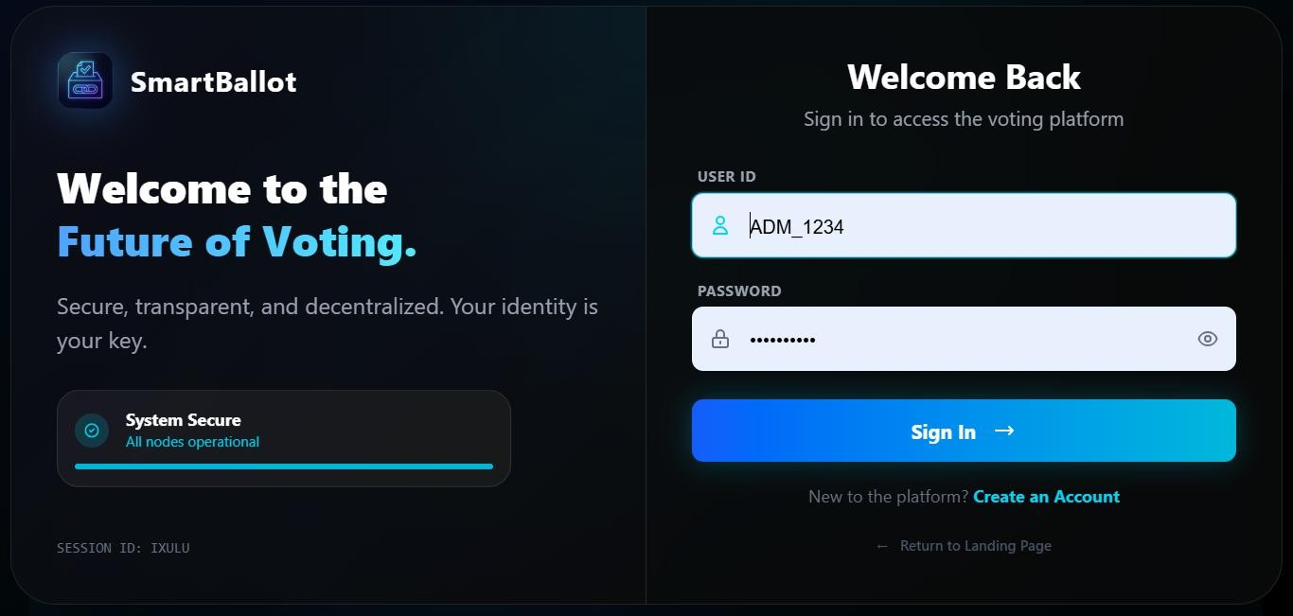
[Figure 4.1: Login Screen showing the user interface for credential entry]

Role-Based Routing and Redirection
The React frontend utilizes a ProtectedRoute component (client/src/components/auth/ProtectedRoute.tsx) to enforce access control. This Higher-Order Component acts as a security guard for client-side routes:
      - It intercepts navigation attempts to restricted pages.

      - It verifies if the user is authenticated via the AuthContext.

      - It checks if the user’s role exists within the allowedRoles array defined for that specific route.
If a user lacks the necessary permissions, they are automatically redirected. The
LoginPage logic handles post-login redirection dynamically:

      - Super Admins are routed to /super-admin.

      - Admins are routed to /admin.

      - Voters are routed to /vote.

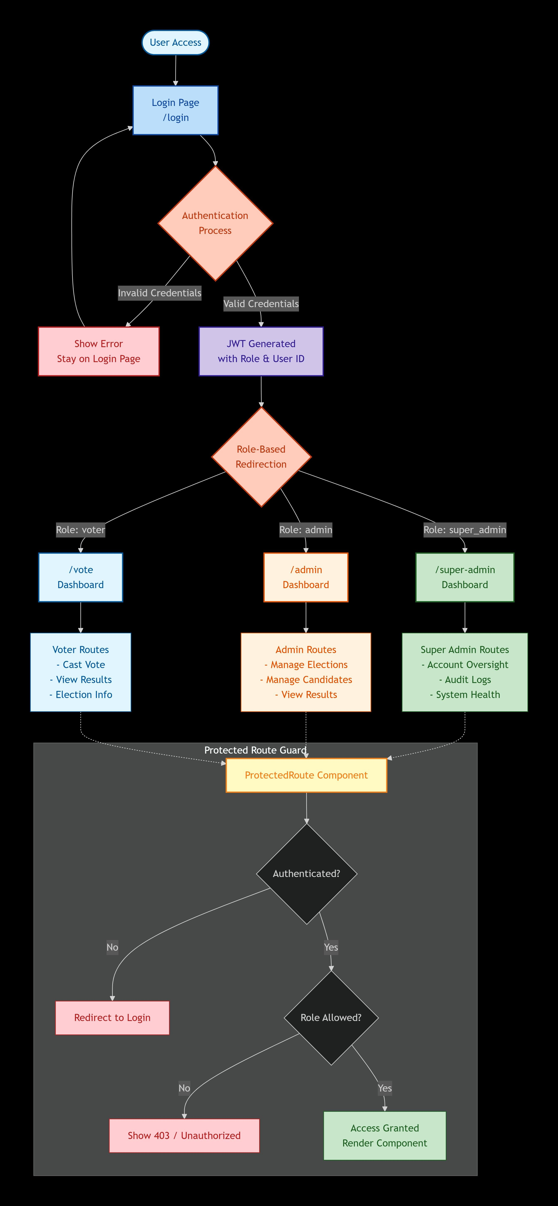

[Figure 4.2: Role-Based Navigation Diagram illustrating the redirection logic]

Role-Specific Dashboards
The system provides tailored dashboard interfaces to present relevant data and actions for each user role.

Super Admin Dashboard
Implemented in SuperAdminDashboardPage.tsx, this interface focuses on system oversight. It features:
      - Key Performance Indicators (KPIs): Real-time statistics on total population, total votes cast, and active election cycles.
      - System Health Monitoring: Displays alerts regarding failed login attempts and unusual traffic patterns (e.g., multiple unique IPs).
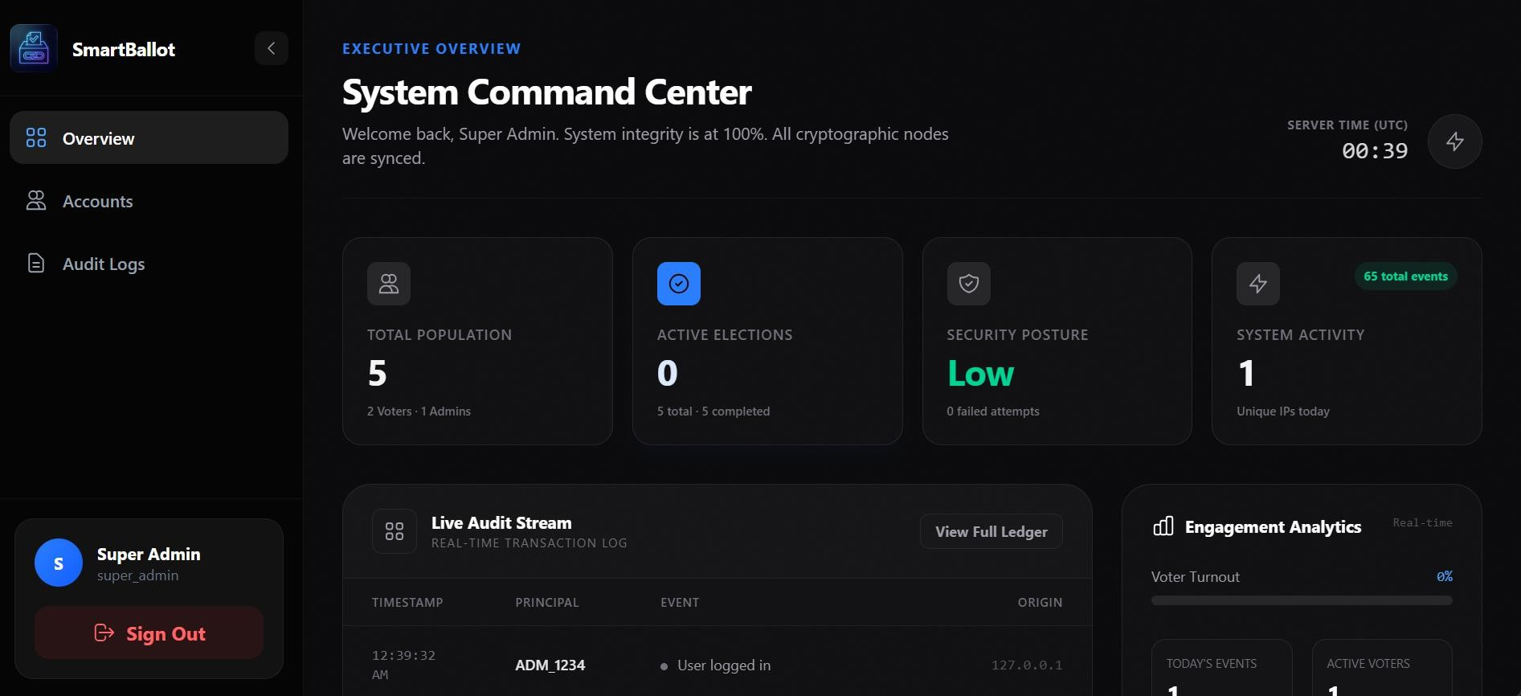
      - Audit Log Summary: A snapshot of recent system activities, categorized by roles, event type and actions performed by those roles.
[Figure 4.3: Super Admin Dashboard displaying system health metrics]

Admin Dashboard
The AdminDashboardPage.tsx serves as the command center for election management. It provides:
      - Election Status Overview: A summary of pending, active, and completed elections.

      - Quick Actions: Direct links to manage candidates, positions, and voter rolls.

      - Recent Activity Logging: A concise view of administrative actions taken within the election modules.
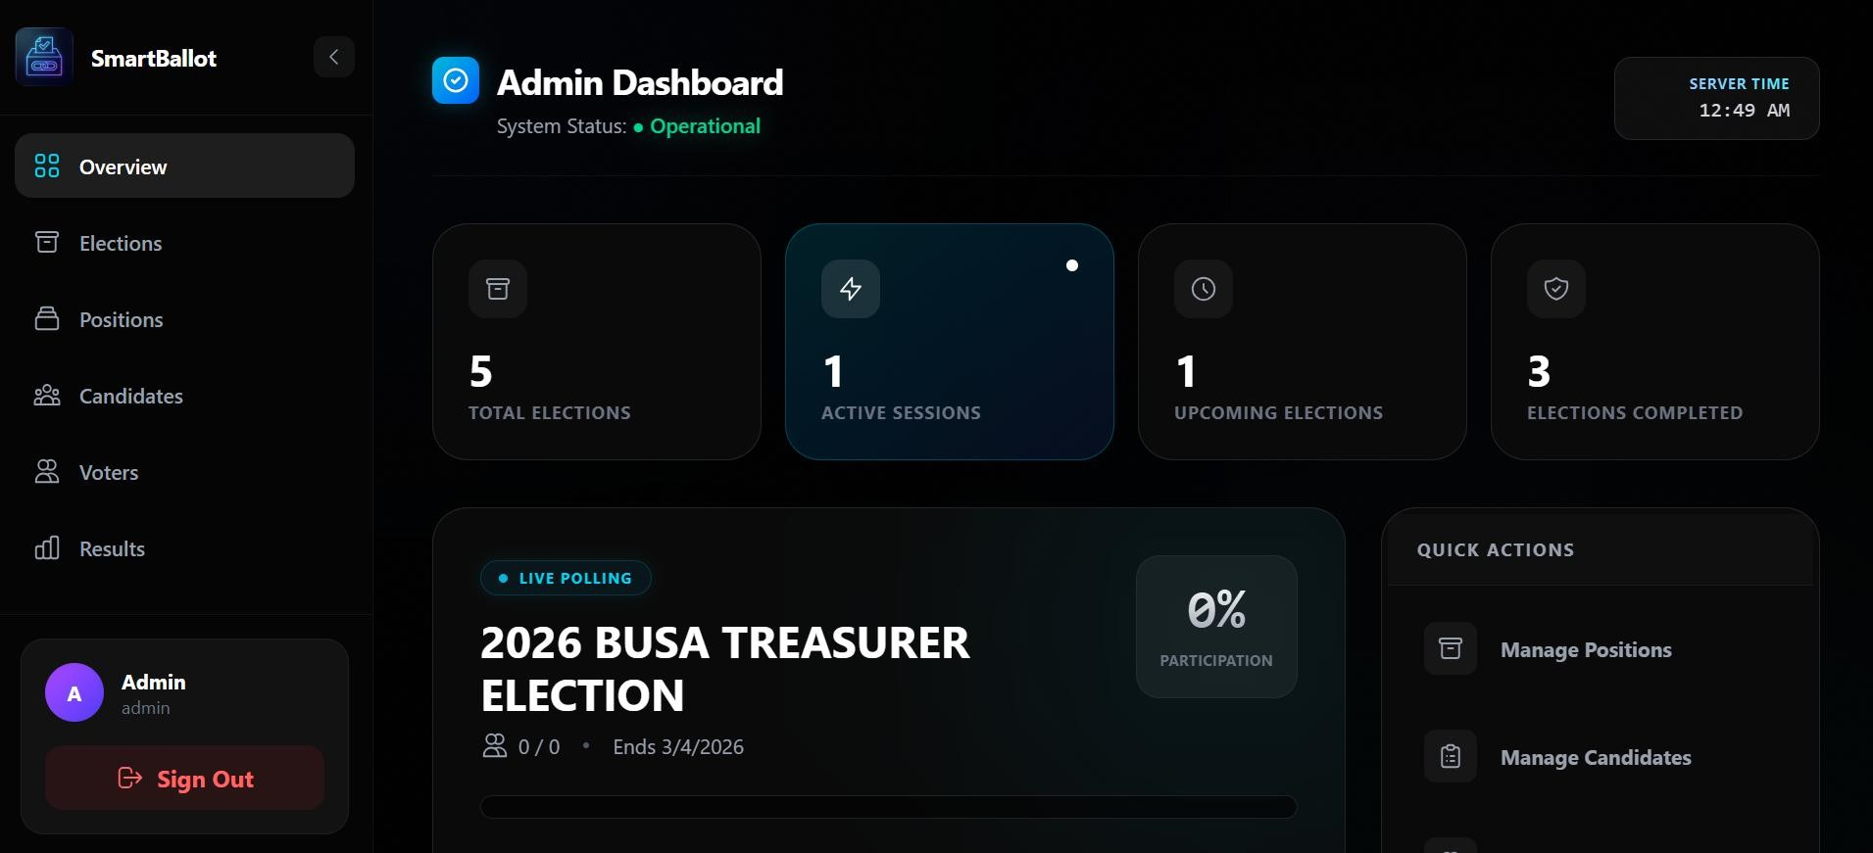
[Figure 4.4: Admin Dashboard showing election management controls]

Voter Dashboard
The LandingPage.tsx serves as the entry point for voters. It presents a streamlined interface that displays:
      - Active Election Information: Details about currently running elections.

      - Candidate Previews: Cards displaying candidate profiles and manifestos (e.g., “Innovation for All”).
      - Instructional Workflow: A visual guide explaining the “Authenticate - Cast Vote - Results” process.
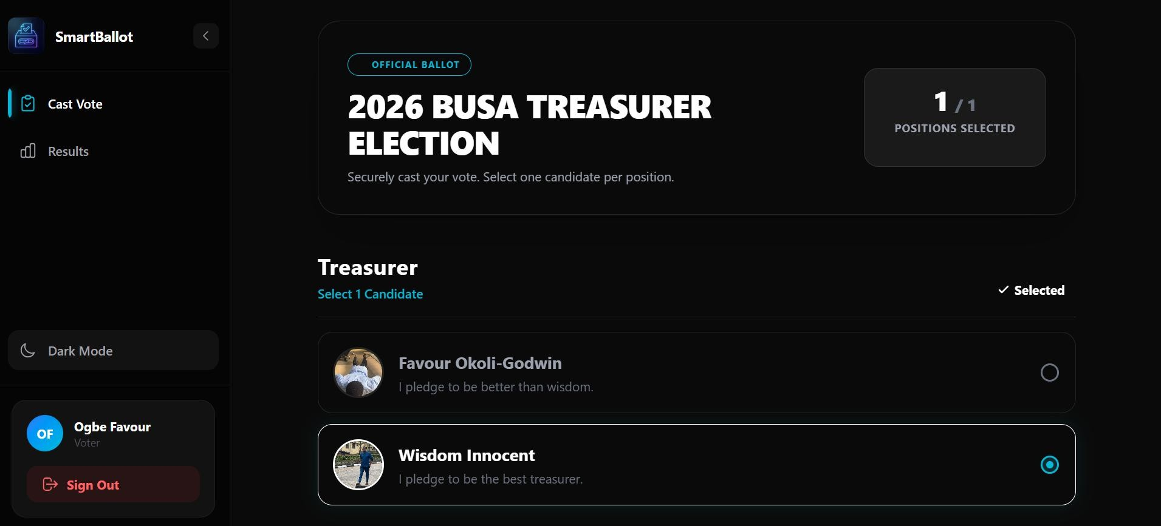
[Figure 4.5: Voters Page showing active elections]

Core Modules and Data Management
The system manages data through a series of CRUD (Create, Read, Update, Delete) modules, primarily accessible to administrative roles.

User and Account Management
Within the AccountOversightPage.tsx, Super Admins can manage the user base. The system presents a tabular view of users (User.findAll model), including their verification status and assigned roles. The interface allows for:
      - Search and Filtering: Real-time filtering by role (Admin, Voter) or specific search queries.
      - Role Assignment: The ability to elevate a Voter to an Admin, or revoke Admin privileges via the userController.js.
      - Verification Status: Administrative validation of user identities before they are permitted to vote.
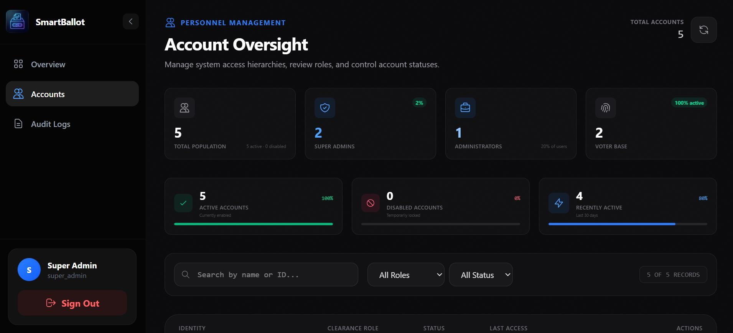
[Figure 4.6: Account Oversight Interface]

Election and Candidate Management
Admins utilize specialized pages (ManageElectionsPage, ManagePositionsPage, ManageCandidatesPage) to configure the ballot.
      - Elections: Created via Election.create, defining titles, descriptions, and active status.

      - Positions: Defines the hierarchy of roles (e.g., President, Secretary) linked to specific elections.
      - Candidates: Profiles are linked to positions, storing biographical data and manifestos in the candidates table.
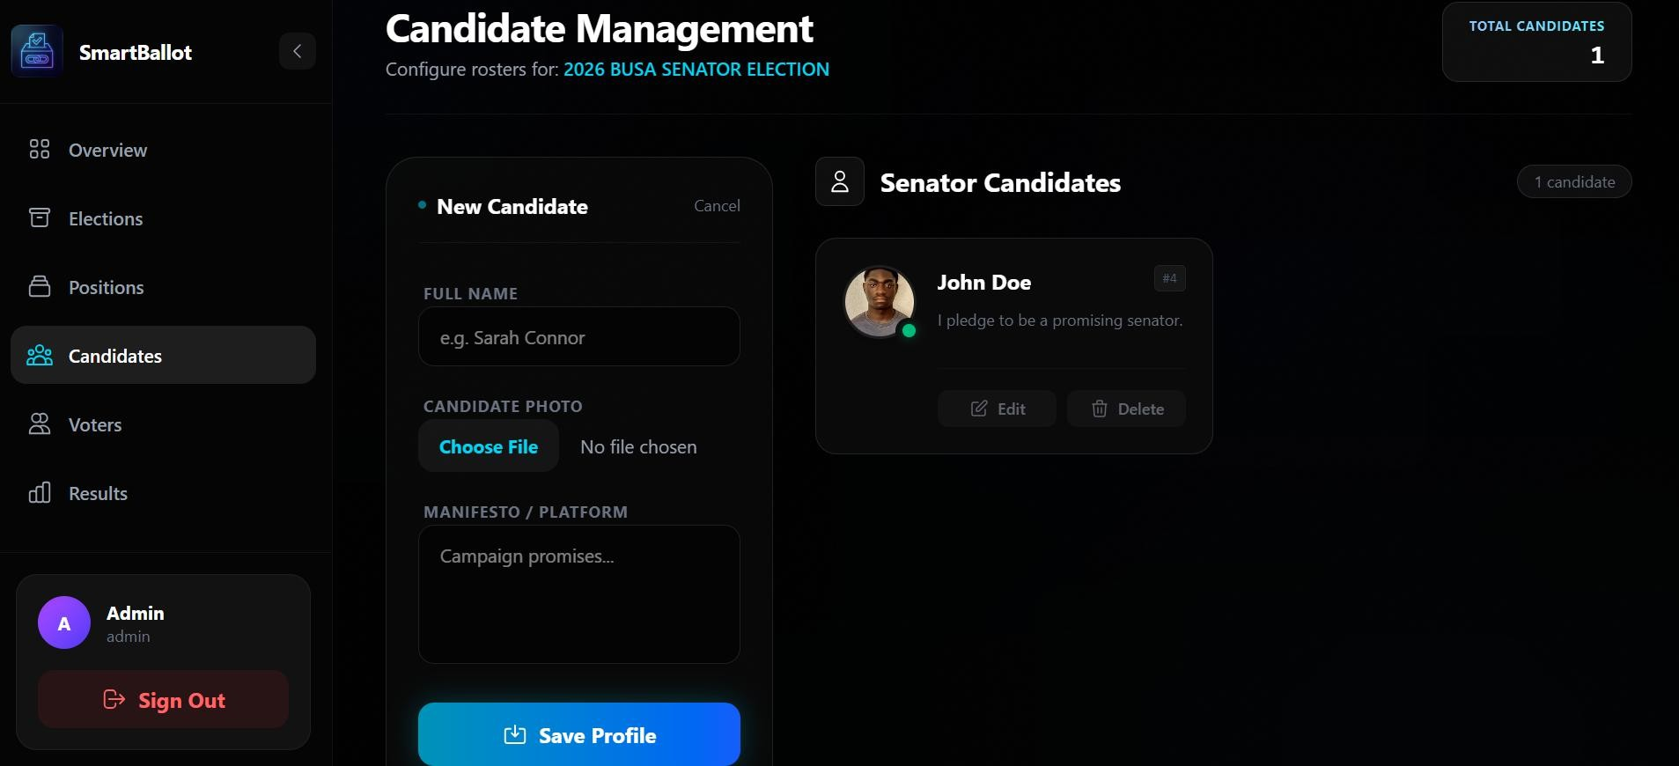
[Figure 4.7: Candidate Management Form]

Processing Workflows

The Voting Workflow
The core transactional workflow of the system is the casting of a vote. This process is handled by the voteController.js and ensures integrity strictly:
- Eligibility Check: The voteMiddleware validates the JWT to ensure the requester is a verified voter. The system strictly cross-references the voter_registry database table (the electoral white-list) to ensure the authenticated user is specifically authorized to participate in the selected election.
- Duplicate Check: The system queries the voter_status table to verify if the user has already cast a ballot for the specific position in the active election.
- Ballot Submission: If eligible, the vote is recorded using MySQL Atomic Transactions. The anonymous vote is inserted into the votes table while the voter's participation status is simultaneously updated to true in the voter_status table. If either database insertion fails, the entire transaction is rolled back, preventing "half-voted" data corruption.
- Time-Bucketing: The system utilizes a “Time Bucketed” insertion method (rounding vote timestamps to the nearest hour) to obscure the exact time a specific user voted, enhancing anonymity while maintaining an audit trail.

Real-Time Monitoring via WebSockets
To provide immediate feedback without page refreshes, the system implements Socket.io.
- Connection: The App.tsx initializes a socket connection upon user authentication.
- Room Assignment: Users are registered into specific socket rooms based on their User ID.
- Broadcasting: Administrative actions, such as “Force Logout” or “Election Status Update,” are emitted from the server (index.js) and received by client listeners to trigger immediate UI updates or alerts.

Specialized Algorithms and Logic

Audit Logging and Anomaly Detection
The system employs an AuditLog model to track sensitive actions. Beyond simple storage, the SuperAdminDashboardPage.tsx implements client-side logic to detect anomalies:
      - Error Rate Analysis: It filters logs for keywords like ‘error’ or ‘fail’. If the frequency exceeds a threshold (e.g., > 5 errors), a system alert is generated.
      - Engagement Metrics: The system actively calculates voter turnout percentages by comparing the total registered voters against the tally of cast votes in active elections.

Cryptographic Security
Passwords are never stored in plain text. The system utilizes the Bcrypt algorithm with a salt round of 10 (bcrypt.genSalt(10)). This ensures that even if the database is compromised, user credentials remain computationally infeasible to reverse-engineer.

Output Generation and Reporting

Election Results Visualization
The AdminResultsPage and VoterResultsPage process raw vote data into consumable visual formats. The resultController.js handles crucial Server-Side Data Transformation. Because the MySQL database returns flat rows of tally data, the Node.js backend executes a grouping algorithm to structure these flat rows into a nested JSON hierarchy (Positions containing an array of Candidates). This prevents frontend rendering crashes and reduces client-side processing load. The frontend then renders this data using:
      - Bar Charts: To compare candidate performance side-by-side.

      - Pie Charts: To visualize the percentage share of votes for each position.

System Audit Export
The AuditLogsPage provides a comprehensive view of system history. While primarily for viewing, this data is structured in a tabular format that is prepared for future export capabilities, allowing administrators to review timestamps, IP addresses, and actions performed by specific Actor IDs.
  - Technology Stack Summary
The following table summarizes the technological components utilized in the implementation of the Online Voting System:
Component Layer | Technology / Library | Description
Frontend Framework | React.js (Vite) | Component-based UI rendering.
Language | TypeScript (Client), JavaScript (Server) | Type-safe logical implementation.
Styling | Tailwind CSS | Utility-first CSS framework for responsive design.
State Management | React Context API & Axios Interceptors | Global state for Authentication and automated secure API request handling.
Backend Runtime | Node.js | Server-side JavaScript execution environment.
API Framework | Express.js | RESTful API route handling and middleware integration.
Database | MySQL | Relational database management system.
Authentication | JSON Web Tokens (JWT) | Stateless user session management.
Real-Time Comm. | Socket.io | Bidirectional event-based communication.
Encryption | Bcrypt.js | Password hashing and salt generation.

CHAPTER FIVE: SUMMARY, CONCLUSION AND RECOMMENDATIONS
5.1 Summary
This chapter presents a summary of the entire research work carried out in this project. The study focused on the design and implementation of an "Online Voting System with Enhanced Security and Transparency" aimed at solving the logistical bottlenecks and integrity concerns associated with traditional voting methods.
The research began in Chapter One with the identification of problems such as high administrative costs and lack of verifiable audit trails. Objectives were formulated to design a secure architecture that ensures voter anonymity and data integrity. Chapter Two reviewed relevant literature and conceptual frameworks, highlighting the importance of cryptographic hashing and decentralized logic in modern digital democracy.
In Chapter Three, the Design Science Research (DSR) methodology and an Iterative SDLC model were adopted. The technical design utilized a decoupled 3-tier architecture consisting of a React.js frontend, a Node.js backend, and a MySQL database. Key security features discussed included structural isolation between user identities and ballots, and the implementation of a Voter Registry to gate participation.
Chapter Four focused on the implementation and rigorous testing of the system. The results demonstrated that the developed system performs efficiently, handling authentication via JSON Web Tokens (JWT) and processing votes through atomic database transactions. The system was tested against various scenarios, including unauthorized access attempts and double-voting simulations, ensuring that the final artifact is robust, reliable, and user-friendly.
5.2 Conclusion
This research work has demonstrated that the application of a 3-tier, computer-based architecture can significantly improve the efficiency, accuracy, and transparency of institutional elections. By separating the presentation, logic, and data layers, the system provides a reliable solution to the challenges of manual voting.
The project successfully met its core goals:
- Voter Anonymity: Enforced through a database design where no direct foreign key link exists between the Users and Votes tables.
- System Integrity: Guaranteed through the use of an "Electoral Roll" (Voter Registry) and verifiable Audit Logs that track all administrative actions.
- Real-Time Transparency: Achieved through an analytics dashboard that provides instant turnout statistics without compromising individual ballot secrecy.
In conclusion, the developed system proves to be a valuable contribution to the field of information technology, offering a scalable framework for conducting secure and transparent digital elections.
5.3 Recommendations
Based on the findings and the successful implementation of this research, the following recommendations are made:
- Institutional Deployment: The system should be deployed for real-life use in academic and corporate organizations to fully utilize its benefits in reducing electoral costs and increasing participation.
- User Sensitization: Stakeholders and voters should undergo brief training sessions to ensure they understand the digital interface and the security measures protecting their privacy.
- Security Auditing: Future administrators should conduct regular security audits of the system’s logs to maintain long-term institutional trust.
- Continuous Maintenance: The system should be updated regularly to address emerging web vulnerabilities and to ensure compatibility with evolving browser technologies.
- Data Integration: Further research can be carried out to integrate the system with existing institutional databases (e.g., Student Information Systems) to automate the voter registry process.
5.4 Future Work
Future researchers are encouraged to build upon this work by exploring more advanced cryptographic technologies. Potential enhancements include:
- Biometric Integration: Utilizing facial recognition or fingerprint scanning to replace password-based authentication for higher security.
- Blockchain Implementation: Transitioning the MySQL "Ballot Box" to a distributed ledger to provide a decentralized, immutable record of every vote.
- AI-Driven Fraud Detection: Incorporating machine learning algorithms to detect behavioural anomalies or bot-like voting patterns in real-time.
These advancements will help in making the system more robust, scalable, and suitable for wider, national-level applications.

